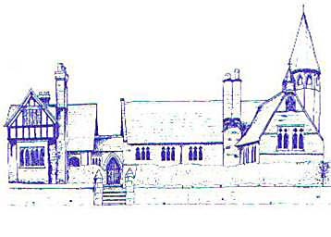

Eccleston C E Primary School
Singing Provision

What does high quality singing provision look like?
- Singing with confidence and together in unison
- An understanding of the importance of warm ups, breathing and posture
- Singing in parts
- Use of dynamics and phrasing
- An understanding of good vocal health
- Singing in different languages
- Singing in a range of genres and styles
- Singing with a sense of ensemble and being able to follow a conductor
- Communication both musically and with emotional meaning and expression
- Singing with an understanding of good posture and breath support
- Excellent performance and presentation skills

Eccleston CE Primary School
Singing Audit
Last updated Spring 2022

Is there whole school singing, how regularly and what form does it take? | The children sing weekly in worship and also in weekly songs of worship. We also have a whole school Nativity play performed in the local Village Hall.
Is there classroom singing time on a regular basis? | Yes, through formal music lessons and incidentally. Children rehearse for events such as the Nativity play and Amasing at the Storyhouse Theatre.
Are there whole class instrumental programmes incorporating singing? | Yes. All children from Year 2 upwards learn to play the recorder and this incorporates singing skills. We engage in Wider Opportunities as often as we can with Years 4 & 5 which also incorporates singing skills.
Is there a before school choir, a lunchtime choir or an after school choir? | Yes – weekly Performing Arts Club runs after school.
Is there a boys choir? | No, but boys are very much encouraged to sing and to attend Performing Arts Club.
Does the school engage with vocal provision and CPD from a local, quality provider? | When finances allow.
Does the school signpost pupils to singing events/music centres/choirs run by the local hub? | Yes – Musical Routes Music Hub, Liverpool Philharmonic Children’s Choir, Chester Cathedral Saturday Singing Club

Our children will sing a wide range of songs throughout their time at Eccleston CE Primary School, including songs of worship and traditional rhymes.
We present a whole school musical Nativity every year and the children’s singing forms an important part of this.
In addition, we will explore the following songs.
Rabbit Class
Boom Chick A Boom (Sing for Pleasure)
Have You Brought Your Whispering Voice? (Voices Foundation)
Dr Knickerbocker (Singing Sherlock)
Hello, How Are You? (Voices Foundation)
Teddy Bear Rock And Roll (Singing Sherlock)
Squirrel Class
Si Si Si (Singing Sherlock)
A Ram Sam Sam (Trad)
Shadow (Singing Sherlock)
Mama Mia (Abba)
Heads and Shoulders (Sing Up)
Ah Poor Bird!/Hey Ho, Nobody Home/Rose
Be Thou My Vision

Badger Class
Servant King (Kendrick)
Ghosts (Sing for Pleasure)
Calypso (Junior Voiceworks)
Nanuma (Trad)
Amani Utepe (Singing Sherlock)
Fox Class
Sen Wa De Dende (Trad)
One Moment, One People (Sing Up)
We Are The Champions (Sing Up)
Where Do We Go From Here (Singing Sherlock)

