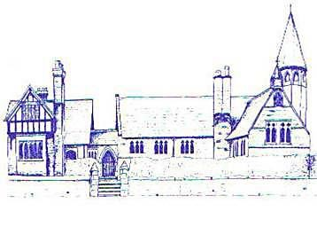
An Early Years Athlete
Age Range | Early Learning Goal | Skills
Reception | Gross Motor Skills | - Negotiate space and obstacles safely, with consideration for themselves and others  - Demonstrate strength, balance and coordination when playing  - Move energetically, such as running, jumping, dancing, hopping, skipping and climbing

