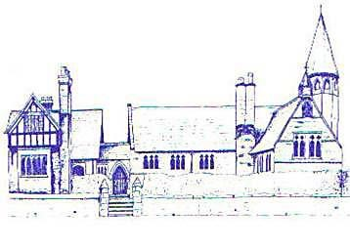
An Early Years Citizen
Age Range | Early Learning Goal | Skills
Reception | Listening, Attention and Understanding | - Listen attentively and respond to what they hear with relevant questions, comments and actions when being read to and during whole class discussions and small group interactions  - Make comments about what they have heard and ask questions to clarify their understanding  - Hold conversation when engaged in back and forth exchanges with their teacher and peers
 | Speaking | - Express their ideas and feelings about their experiences using full sentences, including use of past, present and future tenses and making use of conjunctions, with modelling and support from their teacher
 | Self Regulation | - Show an understanding of their own and feelings and those of others, and begin to regulate their behaviour accordingly  - Set and work towards simple goals, being able to wait for what they want and control their immediate impulses when appropriate
 | Managing Self | - Be confident to try new activities and show independence, resilience and perseverance in the face of challenge  - Explain the reasons for rules, know right from wrong and try to behave accordingly  - Manage their own basic hygiene and personal needs, including dressing, going to the toilet and understanding the importance of healthy food choices
 | Building Relationships | - Work and play cooperatively and take turns with others  - Form positive attachments to adults and friendships with peers  - Show sensitivity to their own and to others’ needs

