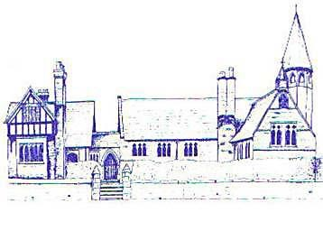
An Early Years Musician
Age Range | Area of Learning |  | Skills
Reception | Expressive Arts and Design |  | - Sing a range of well-known nursery rhymes and songs  - Perform songs with others and move in time with music
 | Physical Development |  | - Move energetically, such as dancing
Early Learning Goal | Listening, Attention and Understanding | Listening and Responding | - Listen attentively to what they hear and respond with relevant questions  - Make comments about what they have heard
 | Expressive Arts and Design |  | - Sing a range of well-known nursery rhymes and songs  - Perform songs with others and move in time with music

