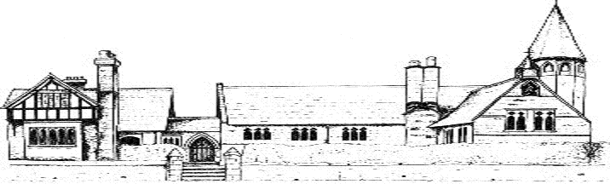
ECCLESTON CE PRIMARY SCHOOL
PHSE PUPIL VOICE

All children were asked to submit their views on the teaching of PHSE at Eccleston in the spring terms of 2022. These are our main findings.
- PHSE is taught weekly
- The overwhelming majority of children enjoy their lessons
- Topics the children said had been taught included how to be safe, how to be healthy, self esteem, how to manage anxiety, how to improve mental health, the dangers of illegal drugs, online safety, goals for our future, how to be a good friend.
- The best things about PHSE lessons were that they were relaxing, being encouraged to share our views, listening to others, being able to talk openly.

