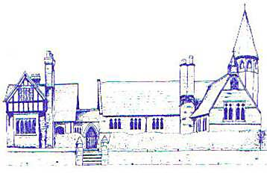

Eccleston C.E. Primary School
Let Your Light Shine

Music Policy

Curriculum Committee

Reviewed: Summer 2023

Approved by Curriculum Committee: Summer 2023

Approved by Full Governing Body: Summer 2023

Signed by Chair of Governors:

Review Date: Summer 2026

ECCLESTON C.E. PRIMARY SCHOOL

Music Policy

Introduction
Music is essentially a practical subject which should be enjoyed by all. From an early age children have an awareness of rhythm, pitch and sounds around them and these should be developed on entry to school.

Intent
At Eccleston CE Primary School we intent to support the children’s learning by:

- Encouraging awareness, enjoyment and appreciation of music in all its forms
- Developing imagination and creativity
- Helping children of all abilities develop positive attitudes and to experience success and satisfaction in music
- Offering opportunities to perform, compose, listen and appraise
- Developing skills and understanding accumatively through increasingly challenging musical tasks and repertoire
- Teaching children explicit musical vocabulary

All children at Eccleston CE Primary School have access to a challenging, broad and balanced music curriculum regardless of gender, race, cultural or social background, special educational needs or being more able learners.

Implementation

- Music is taught weekly at Eccleston CE Primary School as a discreet lesson but also through cross curricular links where possible, e.g. Literacy, Early Years, Maths, P.E. and Art
- As well as class music lessons, whole singing sessions take place weekly and are usually led by the music subject leader
- Pupils are given the opportunity to listen to a range of music at the beginning and end of our Acts of Worship and hymns are sung during some of our Acts of Worship
- Children from Year 1 upwards are invited to join the school Performing Arts Club
- All children are invited to sing regularly in church for such services as Christmas, Harvest, Mothering Sunday and Candlemas
- The Headteacher leads regular whole school worship which include song learning and musical appreciation
- Music lessons are planned using the National Curriculum, the Charanga scheme of work, BBC Ten Pieces and Eccleston’s own bespoke music units
- Children are taught to sing a wide ranging variety of songs and to use their voices expressively
- All children from Year 2 upwards are taught to play the recorder and to read music in the treble clef
- Children are taught to play tuned and untuned percussion instruments with increasing control and an awareness of audience
- Children are given opportunities to perform to bigger audiences at Christmas and at the Chester Storyhouse theatre

Impact
Our expectation is that the majority of children will move through the National Curriculum programmes of study at broadly the same pace. Most children will be working at the expected level for their year group, with some working at above the expected level; greater depth. Those children who are not sufficiently fluent with earlier objectives will consolidate their learning before moving on, using a range of resources and support strategies.

Differentiation

Those children with a particular interest or aptitude in Music can be given the opportunity to extend their education in a variety of ways, for example, individual lessons through Music for Life, Performing Arts Club and instrumental performances in Assembly.

Assessment

Assessment will form an integral part of the teaching and learning of music. This will be done by observing children working and performing, by listening to their responses and by examining work produced.

