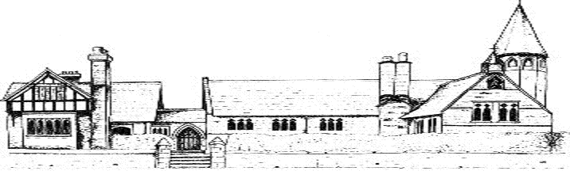

ECCLESTON CE PRIMARY SCHOOL
Let Your Light Shine
History Curriculum Statement
At Eccleston CE Primary School, we are united in our vision to prepare our children for life in the modern world. We will do this by instilling a lifelong love of learning and embedding Christian values that reflect the example Jesus has set. We strive for excellence in all we do, enabling all members of our school to flourish.
“Let your light shine”-Matthew 5.16

HISTORY AT ECCLESTON CE PRIMARY SCHOOL
Intent
Our school’s own rich history, within the context of the local area, is a celebrated and inspiring feature of the school. The history curriculum at Eccleston CE Primary School draws from and makes full use of the immediate and wider local area, enabling children to develop a deep understanding of the rich history of their locality.
Topics are informed by the national curriculum and are sensitive to children’s interests, as well as the context of the local area. The history curriculum at is carefully planned and structured to ensure that current learning is linked to previous learning and that the school’s approaches are informed by current pedagogy. In line with the national curriculum 2014, the curriculum at Eccleston CE Primary School aims to ensure that all pupils:
• Gain a coherent knowledge and understanding of Britain’s past and that of the wider world which helps to stimulate pupils’ curiosity to know more about the past;
• Are encouraged to ask perceptive questions, think critically, weigh evidence, sift arguments, and develop perspective and judgement;
• Begin to understand the complexity of people’s lives, the process of change, the diversity of societies and relationships between different groups, as well as their own identity and the challenges of their time.

Implementation
History is taught in blocks throughout the year, so that children achieve depth in their learning. The key knowledge and skills that children acquire and develop throughout each block have been mapped to ensure progression between year groups throughout the school. At the beginning of each new history topic, teachers refer to classroom timelines to develop children’s understanding of chronology. Each topic is introduced with reference to the chronology of previous topics (including those from previous years). Key knowledge is reviewed by the children and rigorously checked and consolidated by the teacher. By the end of year 6, children will have a chronological understanding of British history from the Stone Age to the present day. They are able to draw comparisons and make connections between different time periods and their own lives. Interlinked with this are studies of world history, such as the ancient civilisations of Greece and the Egyptians.
The school’s own context is also considered, with opportunities for visits to places of historical interest and learning outside the classroom also identified and embedded in practice. Visits to the local area and use of local artefacts, such as the use of maps and photographs, also support contextualised learning, as well as the acquisition of key knowledge and systematic development of key skills.
Planning is informed by and aligned with the National Curriculum. The history curriculum is designed to ensure appropriate diversity in the significant figures that children learn about. Teachers’ cater for the varying needs of all learners, differentiating activities where necessary and as appropriate, and ensuring an appropriate level of challenge. Outcomes of work are regularly monitored to ensure that they reflect a sound understanding of the key identified knowledge.

Learning is practical wherever possible, including trips out of school, visitors in school and the implantation of history immersing activities.

Impact
Outcomes in topic and literacy books evidence a broad and balanced history curriculum and demonstrate the children’s acquisition of identified key knowledge.
Emphasis is placed on analytical thinking and questioning and children demonstrate a coherent knowledge and understanding of Britain’s past and that of the wider world, in addition to being curious to know more about the past. Through this study pupils ask perceptive questions, think critically, weigh evidence, sift arguments, and develop perspective and judgement. Regular heritage projects provide further relevant and contextual learning, engaging members of the community in children’s learning and providing positive role models from the community for children to learn from.

History in the Early Years
At Eccleston CE Primary School, children begin and continue to develop their understanding of history through topic based learning. We also encourage the children to reflect on their own special events and express their own past experiences through imaginative play or celebrations in school.
We provide a learning environment enriched with topic based historical artefacts to enhance children’s curiosity which they can incorporate into their own imaginative play. We also provide a range of high quality texts to reflect history and further engage our youngest pupils.
Children explore their own identity and the world around them and look at similarities and differences with others.

