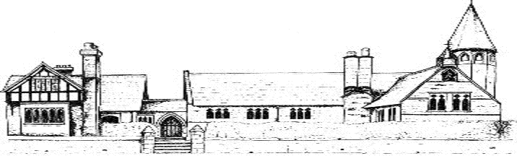

ECCLESTON CE PRIMARY SCHOOL
Let Your Light Shine
Art and Design Curriculum Statement
At Eccleston CE Primary School, we are united in our vision to prepare our children for life in the modern world. We will do this by instilling a lifelong love of learning and embedding Christian values that reflect the example Jesus has set. We strive for excellence in all we do, enabling all members of our school to flourish.
“Let your light shine”-Matthew 5.16

ART AND DESIGN AT ECCLESTON CE PRIMARY SCHOOL
Intent
The art curriculum at Eccleston CE Primary School will develop children’s critical abilities, as well as an understanding of their own and others’ cultural heritages through the study of a diverse range of artists.
Children will develop their understanding of the visual language of art with effective teaching and considered sequences of lessons and experiences. Understanding of the visual elements of art and design (line, tone, texture, colour, pattern, shape, 3D form) will be developed by providing a curriculum which will enable children to reach their full potential.
Implementation
Our pupils develop their understanding of the visual language of art with effective teaching and considered sequences of lessons and experiences. Understanding of the visual elements of art and design will be developed by providing an engaging curriculum.
We teach a skills based curriculum and offer opportunities for children to express their creative imagination and record ideas, observations and experiences.
Sketchbooks are used extremely effectively and provide a record of children’s progress and achievements. There are explicit links to other curriculum areas, including humanities, with children developing a considerable knowledge of individual artists, as well as individual works and art movements.
Lessons are taught by a specialist art practitioner.
Impact
The structure of the art curriculum ensures that children are able to develop their knowledge and understanding of the work of artists, craftspeople and designers from a range of times and cultures and apply this knowledge to their own work. Children learn to understand and apply the key principles of art: line, tone, texture, shape, form, space, pattern, colour, contrast, composition, proportion and perspective. The opportunity for children to refine and develop their techniques over time is supported by effective lesson sequencing and progression between year groups. This also supports children in achieving age related expectations at the end of their cohort year.
Classroom displays reflect the children’s sense of pride in their artwork and this is also demonstrated by creative outcomes across the wider curriculum.
Art in the Early Years
Children in our Early Years are encouraged to represent their own ideas, thoughts and feelings through art. They will do this by safely using and exploring a range of materials, tools and techniques, experimenting with colour, design, texture and form. Encouraging attitudes of curiosity and questioning as well as skills and techniques is important when supporting the progression of the children’s creativity and confidence in their ideas and skills.

