ECCLESTON CE PRIMARY SCHOOL
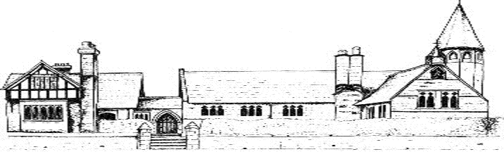
FRENCH EDUCATION CURRICULUM
CYCLE A
 | Autumn | Spring | Summer
Class 2 | Numbers 0 -10 Greetings, asking and saying how you are Christmas – nativity and Christmas vocabulary, letter to Father Christmas | Classroom instructions Ask for and give name Revision of numbers 0 – 10 Ask for and state age Colours Making a pancake Easter | Names of fruit Names of other foods Days of the week Months of the Year General recap
Class 3 | Revision of colours  Parts of the body  Adjectives  Asking for French translation (Comment dit-on… en français?) Zoo animals Verb – être (to be) Christmas – phrases and vocabulary for work on snowman theme | Song ‘Meunier tu dors’ Members of the family Possessive adjectives  Ask and answer questions about family members Story ‘Le Radis Géant’ (The Enormous Turnip) Pets Verb – avoir (to have)  Easter vocabulary | Dictionary skills  Playground song and activity  Hobbies  Opinions Numbers 12 -31 Weather expressions Items of clothing – packing a suitcase
Class 4 | Classroom routines (answering the register, saying the date, describing the weather, asking for classroom objects, following instructions)  Recap of simple negative As -tu...?  Recap of clothes vocabulary  Recap of expressing opinions  Justifying opinions C’est + adjective Recap of family members  Recap of verb être  Occupations  Christmas vocabulary | Phrases to use when playing games in French  Rooms of the house  Recap of adjectives from Y4/5  Une fenêtre, une piscine  Recap of prepositions from Y5 Furniture vocabulary  Recap of ‘stalling’ strategies from Y5 Recap of days of the week and months of the year from Y3, Y4 and Y5  Recap of verb aller from Y5: on va  Easter vocabulary | Planning a trip: On va rester dans... (un hôtel, un appartement, un gîte, un camping) On va aller, prendre Recap of means of transport (en bateau, en avion, en voiture, en train) On va visiter… regarder… D’abord, plus tard Names of places to visit

CYCLE B
 | Autumn | Spring | Summer
Class 2 | Seasons Christmas Nativity play – Characters in the nativity play and simple dialogue | Work based on ‘La chenille qui fait des trous’ (The Hungry Caterpillar)  Revision of: Names of foods Days of the week Months of the year | Work based on ‘Arc-en-ciel le plus beau poisson des océans’ (The Rainbow Fish) Animals
Class 3 | Buildings on the high street  Directions  Revision of adjectives  Revision of connectives  Asking where places are  Revision of days of the week  Times of day  Christmas vocabulary | Revision of days of the week  Revision of sports/hobbies  Simple future tense (Je vais…)  Numbers 0 – 50  Comparisons (plus que – more than) Revision of fruit/food vocab | Breakfast  Ingredients for a French dessert (instructions)  Revision of days of week/months of year Weather  Seasons  Saying where you live
Class 4 | Classroom routines (answering the register, saying the date, describing the weather, asking for classroom objects, following instructions)  Recap of simple negative As -tu...?  Recap of clothes vocabulary  Recap of expressing opinions  Justifying opinions C’est + adjective Recap of family members  Recap of verb être  Occupations  Christmas vocabulary | Phrases to use when playing games in French  Rooms of the house  Recap of adjectives from Y4/5  Une fenêtre, une piscine  Recap of prepositions from Y5 Furniture vocabulary  Recap of ‘stalling’ strategies from Y5 Recap of days of the week and months of the year from Y3, Y4 and Y5  Recap of verb aller from Y5: on va  Easter vocabulary | Planning a trip: On va rester dans... (un hôtel, un appartement, un gîte, un camping) On va aller, prendre Recap of means of transport (en bateau, en avion, en voiture, en train) On va visiter… regarder… D’abord, plus tard Names of places to visit

