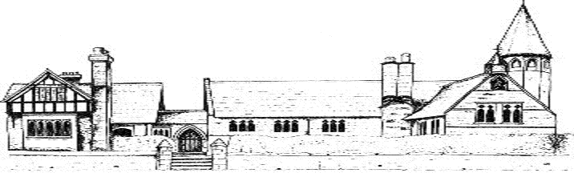
Eccleston CE Primary School Curriculum Statement
Intent
At Eccleston, our curriculum is inspired by our mission statement (Let Your Light Shine), vision and aims. We believe that children should experience excellent teaching and develop a deep love of learning through an ambitious curriculum. In delivering our inclusive curriculum, we aim to remove any barriers to learning so that ALL children are able to make progress. Our school curriculum uses the National Curriculum as a starting point which is tailored to the needs of our children at Eccleston. We aim to ensure that all children are confident, articulate and effective communicators by the time they leave our school. We want all of our children to develop an ‘I can’ attitude towards their learning and a strong resilience to challenge, understanding the importance and the value of making mistakes. We aim to ensure that all children have a secure understanding of fundamental British Values, as well as our own Eccleston Christian values. Furthermore, our children, gain an understanding of equal opportunity and are able to celebrate the richness and diversity of the society in which they live and are fully prepared for life as a global citizen. Through the curriculum, we want our children to be able to make positive choices in terms of their social interactions, health and personal well-being. A key approach to achieving our curriculum intent is for our curriculum to be filled with enriching first-hand experiences.
To ensure an ambitious, quality curriculum for all pupils we have considered the following;
- Statutory requirements
- Local context
- Putting reading at the heart of the school
- Subject leadership

Implementation
Our curriculum incorporates the statutory requirements of the National Curriculum 2014 and a range of other experiences and opportunities which best meet the learning and developmental needs of the children in our school. It is our responsibility to develop literacy and numeracy skills for all our pupils. Using the Early Years Foundation Stage and the National Curriculum, age appropriate progression in vocabulary, knowledge and skills for each core and foundation subject has been identified. This has been mapped out in the form of ‘end points’ for years 1, 3, 5 and 6. We carefully select the sequence of when, what and how vocabulary, knowledge and skills are taught and Subject Leaders work actively to review this regularly.
This approach enables project based learning, fostering each child’s curiosity and interest as well as the achievement of depth in knowledge and skills.
Staff awareness of the end points from previous years ensures regular reinforcement of vocabulary, knowledge and skills. Teachers systematically check children’s understanding and identify misconceptions, providing clear, direct feedback to ensure progress. Teaching is designed to help learners to remember in the long term the content they have been taught and to integrate new knowledge into larger concepts.
We provide the children with memorable experiences in addition to diverse and rich opportunities from which our children can learn and develop a range of transferable skills.
Opportunities to practise knowledge and skills are built into the curriculum to secure deep understanding in each discipline. Reading is at the heart of our curriculum and opportunities to reinforce and introduce new skills and utilised across the curriculum.
We offer a varied timetable for extracurricular activities, with clubs that support the core curriculum offer whilst extending the range of children’s experiences.
Our varied charity work provides our children with a sense of global citizenship and aids an appreciation of our lives and all we have to be thankful for.
Subject Leaders play a vital part in the success of our curriculum by monitoring, evaluating, reviewing and celebrating good practice.
The Performing Arts has a high profile in school and our children are offered many opportunities to perform in school and beyond.
Pastoral care is strong at Eccleston CE Primary. Our Emotional Literacy Support Assistant works across all classes delivering wellbeing activities as well as the Kidsafe programme. We employ a play based therapist to offer children extra support as appropriate. Our PHSE curriculum is strong and offers our pupils a safe place in which to explore sensitive issues.
Impact
The impact of our curriculum is evident in the outcomes for pupils;
- Engage and motivated children who take learning with them, prepared for the next stage of their education
- Assessment data which reflects progress made against national expectations
- Application of knowledge and skills in different contexts
- Embedding knowledge and skills through regular opportunity to practice and rehearse prior learning
- A learning environment which is vibrant and reflects the rich and varied opportunities our children encounter
- Learners are ready for the next stage of their education; confident and prepared to embrace opportunities and follow their interests and aspirations
- An understanding of their place in the world and their responsibility as global citizens

