Catch-up funding action plan

Contextual information
School name | Eccleston CE Primary School | Headteacher | Katie Prescott | Academic year | 2020 to 2021
Number of pupils | 98 | Funding allocation | £ 7,840 | % PPG pupils | 8

Background
The government announced £1 billion of funding to support children and young people to catch up lost time after school closure due to the pandemic. This is especially important for the most vulnerable and disadvantaged backgrounds. For primary schools this funding includes:
- a one-off universal £650 million catch up premium for the 2020 to 2021 academic year to ensure that schools have the support they need to help all pupils make up for lost teaching time; and
- a £350 million National Tutoring Programme to provide additional, targeted support for those children and young people who need the most help, which includes: a school’s programme for 5 to 16-year-olds – for more information, see the National Tutoring Programme FAQs, and an oral language intervention programme for reception-aged children.

The school’s funding allocation will be calculated on a per pupil basis. A mainstream primary school will get £80 for each pupil in from reception to year 6 inclusive. The school will receive funding in 3 tranches – 1. autumn 2020 – this is based on the latest available pupil data in the October census; 2. Early 2021 – based on updated pupil and place data. This payment will also take account of the initial part payment made in autumn 2020 so that the school will receive a total of £46.67 per pupil or £140 per place across the first 2 payment rounds; and 3. summer 2021 term - a further £33.33 per pupil or £100 per place.

The DfE guidance states ‘Schools should use this funding for specific activities to support their pupils to catch up for lost teaching over the previous months, in line with the curriculum expectations for the next academic year in actions for schools during the coronavirus outbreak. While schools can use their funding in a way that suits their cohort and circumstances, they are expected to use this funding for specific activities which will help pupils catch up on missed education.’
Ref: Catch up premium, published 19 November 2020
Purpose of the action plan
- To evidence how the school is using the COVID-19 funding to resume teaching the full curriculum following partial closure in the summer term 2020
- To evidence how the school is using the funding for specific activities to support pupils to catch up as a result of lost teaching in the summer term 2020
- To enable governors and trustees to scrutinise the school’s plan for and use of catch-up funding. This includes consideration of whether the school is spending the funding in line with their catch-up priorities, and ensuring appropriate transparency for parents.

Accountability
Written by | Katie Prescott | Approved by governors | October 2020
Updated | October 2020 | Reviewed by governors

Rationale for use of funding
Our spending has been allocated based upon the Education Endowment Foundation (EEF) evidence-based approaches for catch-up in the document coronavirus (COVID-19) support guide for schools and using the recommended implementation strategies in the EEF document school planning guide: 2020 to 2021.
Our strategic approach to the use of funding
We have adopted the 3-tier approach recommend by the EEF
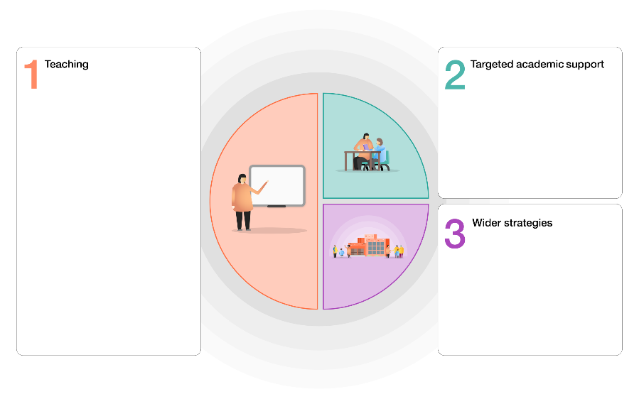
Tier 1 Teaching and whole school strategies
- Supporting great teaching
- Pupil assessment and feedback
- Transition support

Tier 2 Targeted approaches
- One to one and small group tuition
- Intervention programmes
- Extended school time

Tier 3 Wider strategies
- Supporting parent and carers
- Access to technology
- Summer support

Our catch up priorities |  |  |  |  | Evidence base
English – writing
- To increase stamina for writing and develop essential writing skills
- To close the gap in writing between children disadvantaged during school closure and those less disadvantaged by school closure
- To address specific gaps in knowledge of grammar, punctuation and spelling

English – reading
- To increase stamina for reading challenging texts
- To ensure quality first teaching of phonics through the purchase of a robust and recommended scheme
- To develop reading skills lost during school closure
- To close the gap in reading between children disadvantaged during school closure and those less disadvantaged by school closure
- To further develop comprehension skills
- To maintain and develop a love of reading
- To target the lowest attaining 20% of readers across school

Mathematics
- To address specific content that has been missed, leading to gaps in learning and stall sequencing of learning
- To develop basic skills lost during school closure, i.e. multiplication facts and calculation strategies

Wider curriculum
- To address anxieties concerning the pandemic and ensure that all children feel safe and secure in school and well supported emotionally

Tier 1 Teaching and whole school strategies
Intent | Implementation of strategy | Cost | Monitoring | Impact
Quality first teaching  Foundation subjects will be planned with increasing detail and consideration for how pre-requisite knowledge will be taught alongside new learning so that knowledge gaps can be reduced.  The teaching of phonics will be robust throughout EYFS and KS1. Pupils in danger of falling behind will be identified quickly and extra support will be put in place. All teachers/Teaching Assistants will be confident in the teaching of phonics and it will be consistent across school | The purchase of high quality units of work to support the teaching and learning of reading skills will support quality first teaching and ensure that stamina and motivation are improved in reading across the curriculum.  Training on how best to use these units to address gaps in learning from a literacy consultant.  Purchase of a high quality and recommended phonics scheme | £2,100  £300 training  TBC
Pupil assessment and feedback  Teachers have a very clear understanding of what gaps in learning remain and use this to inform assessments of learning that are aligned to standardised norms, giving a greater degree in confidence and accuracy of assessments | Whole staff training on effective feedback | £300 training

Tier 2 Targeted approaches
Intent | Implementation of strategy | Cost | Monitoring | Impact
One to one and small group tuition  Identified children will have significantly increased rates of reading fluency and prosody. They will be able to comprehend reading better as a result of being able to read at pave without spending their working memory decoding. They will be confident readers and dips in reading attainment will be negated. | Cover for classes required in order to release teachers to work with targeted groups. | 22 afternoons cover - £2200
Intervention programmes  An appropriate numeracy intervention will support those identified children in reinforcing their understanding of basic maths skills and application of number. | Quality Teaching Assistant time. | 24 afternoons  £1600
Extended school time  Identified children will be able to access a weekly catch up club. The attainment of those identified children will improve and the effect of lockdown becomes reduced. | Teacher time | 48 hours  £960

Tier 3 Wider strategies
Intent | Implementation of strategy | Cost | Monitoring | Impact
Supporting parent and carers  Children will have greater opportunities to access learning at home. Home learning opportunities will not always require parental engagement, thus affording the children greater independence and increasing the likelihood that parents can sustain home learning.  Children have access to appropriate stationary and paper based home learning if required so that all can access learning irrespective of ability of child/parent to navigate online learning. | Purchase of White Rose home learning.  Two day home learning paper packs are printed and ready to distribute for all children.  Stationary packs have been distributed to all children in case of home learning. | £300  £200
Access to technology  Teachers have lap tops equipped with webcams which allow them to access school based resources and communicate with classes from home.  Teachers have had training on Google classroom. |  | Google Classroom training £300
Summer support

Summary
 | Cost | Impact summary statements
Tier 1 Teaching and whole school strategies | £2,700
Tier 2 Targeted approaches | £4,760
Tier 3 Wider strategies | £500
 | Total expenditure £7960

