The Story of Creation
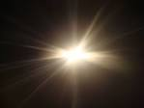
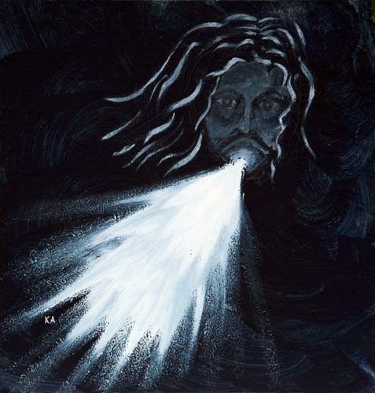

By Class 4

Empty space, inky, black darkness, nothingness surrounds the place
God fashioned a sphere with his hand…
Salty, freezing, turquoise water consumes the land and my hope.
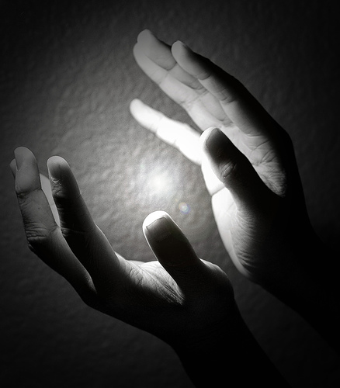
I look.
I see sea.
I feel lonely…

I feel light! I feel warmth! Bliss!
I turn – what a light! My eyes! My eyes! I’m blinded!
I smell the smell of God’s hand, reaching out in the earth, dividing the light from the darkness.
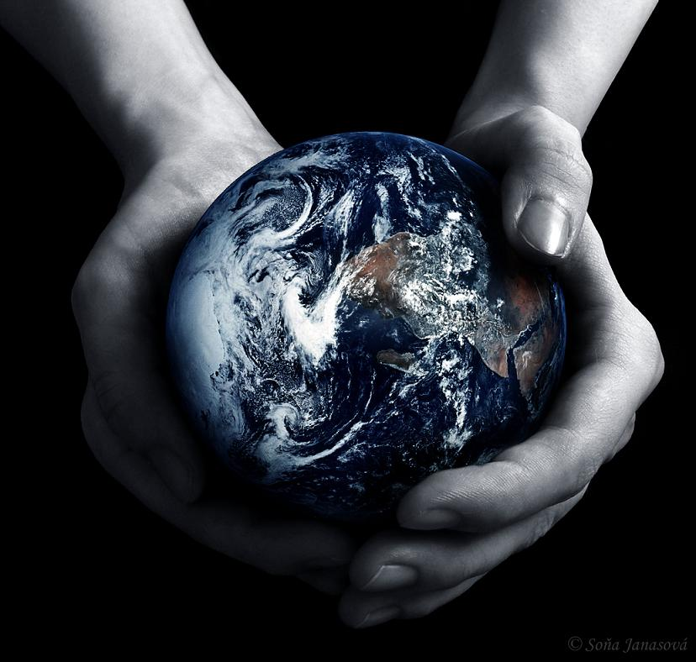
I taste hope, then a voice speaks,
“You shall be healed”, before all goes dark.
It is night.
I close my newly reformed eyes. Thank you God.
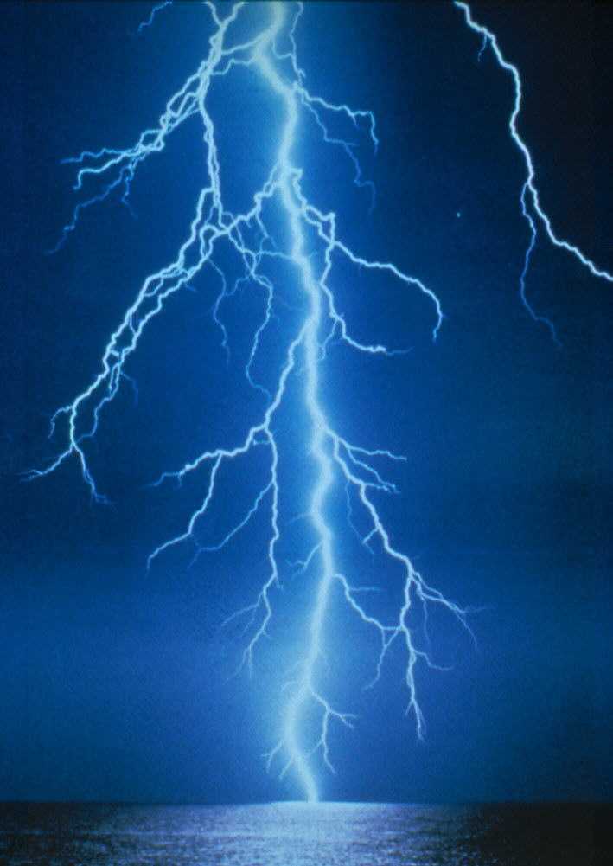
The glistening sky,
Running across the earth,
The clouds crack – and lightning!
How it shoots!
Quite brilliant
The stormy nights of November and the cold snowy nights of December.
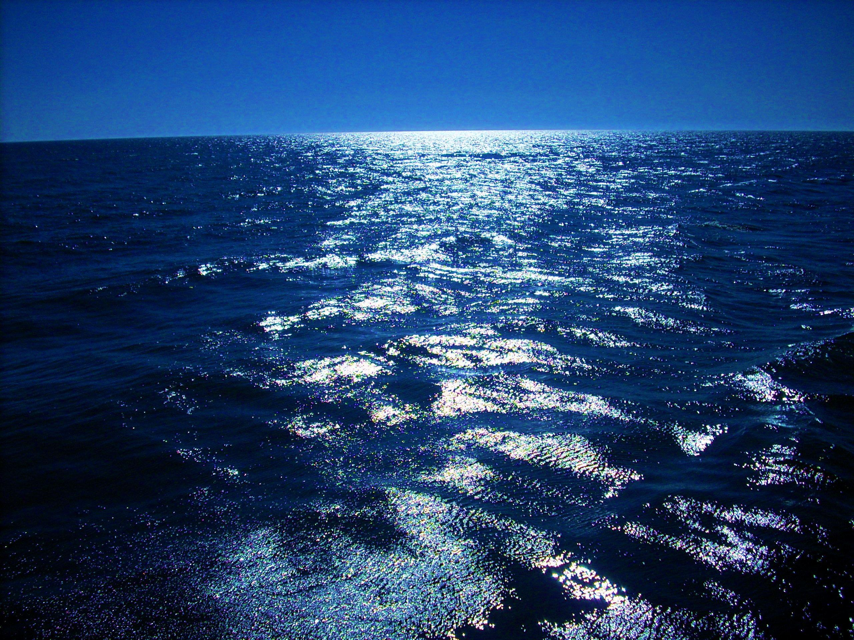

Amazing rich waters
Of the beautiful seas,
Tiny ponds and vast oceans
Streams glistening in the sunlight as they follow their path to the fabulous seas.

Brown soil, lush green grass, pretty, fragrant petals,
And the breeze, the breeze, the beautiful breeze,
Cluttering through the huge, tall trees.
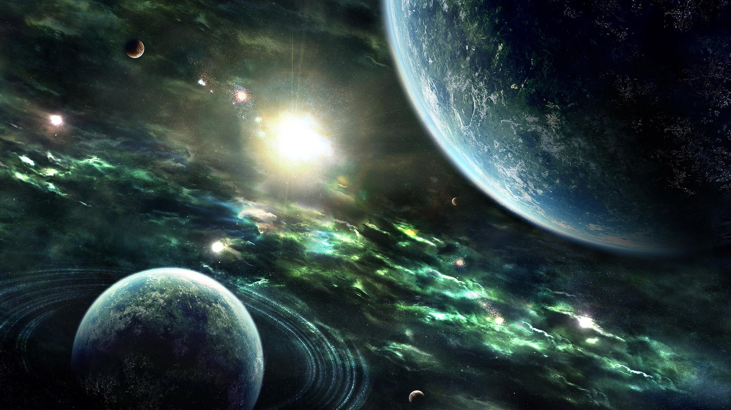
A sky of blue and black,
Glimmering shapes that are stars
And a glowing sphere of goodness.
The summer sun reflects on my skin.

The cool, green waters stretch out in God’s new world.
The shark pounces on a vulnerable fish,
The dolphin moves gracefully through the sea.

Pretty feathers glistening in the golden sunlight,
The array of rainbow colours peeking through the trees.
God’s birds dance and sing before my eyes,
They tweet and hum as the breeze flies past me.

Walking, hearing now the sound of monkeys and chimpanzees,
Gazing up at the long necked giraffe,
The animal, the patterns – the spots and stripes,
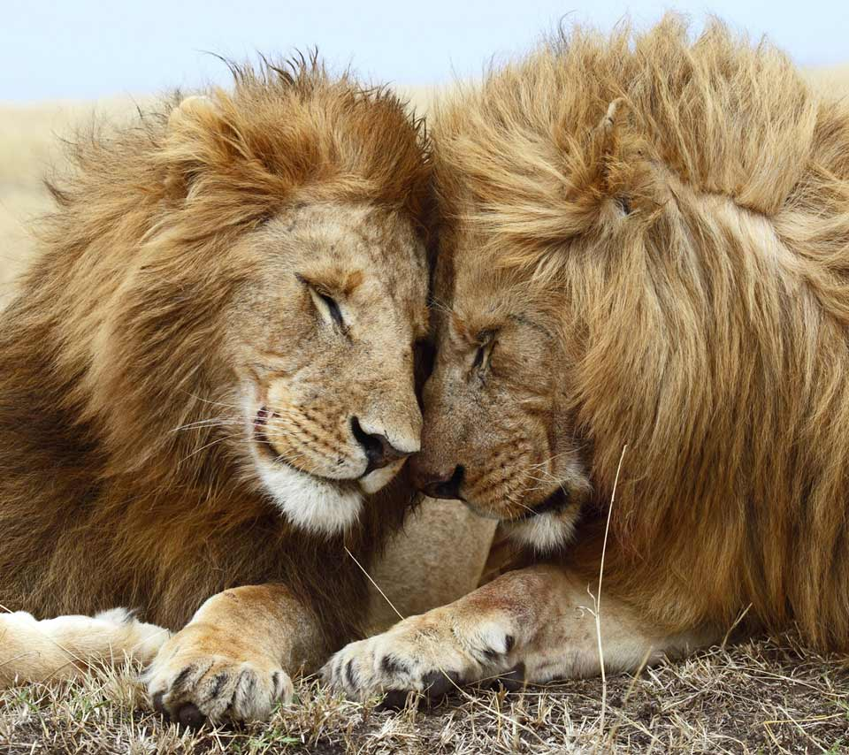
The birds’ song.
Roaring lions,
Hissing lizards,
Galloping horses.

The humans now gaze up at the sun,
Dancing and laughing at the glittering sun as it shows the start of another new day.
Naming the creatures as they gaze upon them.
Time slips away and the stars and the bright moon glisten.
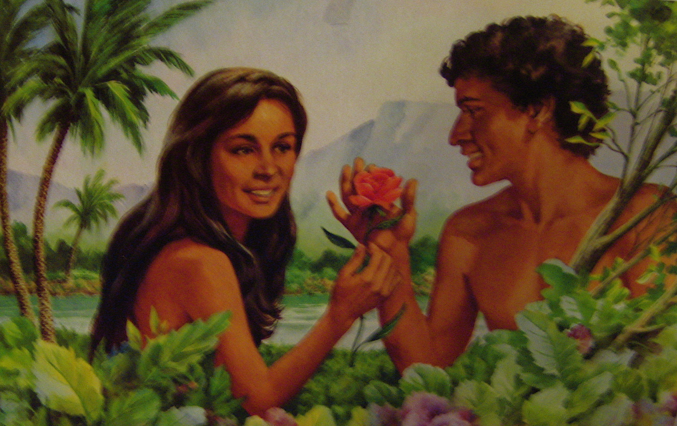
Settling to sleep now
In God’s wonderful new creation.

