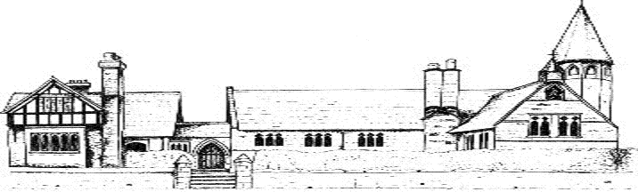

ECCLESTON CE PRIMARY SCHOOL
GOVERNOR ATTENDANCE AT FGB MEETINGS 2021/2
Name | Autumn FGB | Spring FGB | Summer FGB
Mr N Southorn
Mrs H Glaze |  | A | A
Mr J Williams
Mr R Hughes | A |  | A
Mrs S Willan
Miss C Willan
Mr K Ivens
Mrs H Campbell |  |  | A
Mr S Miller
Mrs J Howe
Mr A Allmark
Mrs A Killick
Mrs K Prescott
Mrs S Weaden

