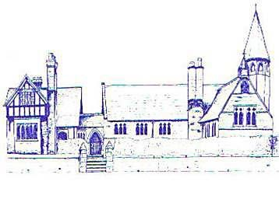
An Early Years Designer
Age Range | Early Learning Goal | Skills
Reception | Fine Motor Skills | - Use a range of small tools, including scissors, paint brushes and cutlery
 | Creating With Materials | - Safely use and explore a variety of materials, tools and techniques, experimenting with colour, design, texture, form and function

