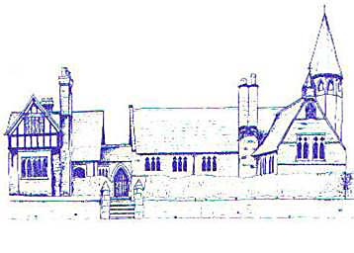

Eccleston C.E. Primary School

Let Our Light Shine

Governor Allowances Policy

Reviewed: Spring 2024

Approved by Full Governing Board: Spring 2024

Signed by Chair of Governors:

Review Date: Spring 2026

Overview

This policy is designed to outline the circumstances in which the governing body of Eccleston C of E Primary has the discretion to pay allowances from the school’s annual budget which they incur in carrying out their duties.

- Governors may claim allowances in respect of actual expenditure incurred whilst attending meetings of the governing body and its committees, undertaking governor development and otherwise acting on behalf of the governing body:

- Governors may not claim for actual or potential loss of earnings or income, or claim an
attendance allowance.

- All governors and associate members are eligible to claim allowances in accordance with this scheme.

Eligible Expenses

Categories of eligible expenditure are as follows:

- Travel
Travel expenses may be claimed where the distance between the governor's home and the
school is greater than 5 miles. The Headteacher and any governor who is employed at the
school will not be eligible to claim unless an additional return journey has been made to
attend.

- Care arrangements
Child care or baby sitting expenses, where these are not provided by a relative or
partner. Care arrangements for an elderly or dependent relative, where these are not
provided by a relative or partner.

- Telephone calls and postage

- Subsistence

Allowance Rates

Rates at which allowances are payable are as follows:

Travel Rates
In accordance with HMRC mileage allowance, which is 45p per mile for
cars and vans and 24p mile for motorcycles.
For public transport, actual costs incurred. For travel by taxi the
cost must not exceed [£15] per journey.

Care Arrangements Actual costs incurred, up to a maximum of [£15] per hour

Telephone Calls and Postage Actual costs incurred.

Subsistence
If additional expenses are incurred because work as a governor requires
taking meals (i.e. breakfast, lunch or dinner) away from your school area,
reimbursement will be made for the food/drink items bought on the day
claimed.

Criteria for Claims

All claims must be submitted to the Head Teacher and Chair of Finance Committee within
one month of the expenditure being incurred.

Receipts must be supplied to support claims for reimbursement, e.g. bus ticket, phone bill,
taxi receipt, till receipt.

In the case of telephone calls, an itemised phone bill should be provided, identifying the
relevant calls.

9. Governors wishing to make claims under these arrangements, once prior approval has been
sought, should complete a claims form obtainable from the School Office.

10. Claims will be subject to independent audit and may be investigated by the Chair of
Governors (or Chair of Finance in respect of the Chair of Governors) if they appear
excessive or inconsistent.

