ECCLESTON CE PRIMARY SCHOOL
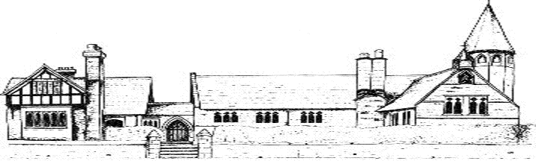

DESIGN AND TECHNOLOGY CURRICULUM
CYCLE A/CYCLE B
 | Autumn | Spring | Summer
Class 1 | Puppets  Baking  Junk Modelling  Make and decorate Christmas cakes  Moving pictures  Design and make Christmas tree decorations  Baking  Junk Modelling | Grouping goods and cooking  Moving pictures  Junk Modelling  Puppets  Design and make a superhero mask  Baking  Junk Modelling | Design and make a sea creature  Baking  Junk Modelling  Boat models  Sorting and grouping foods  Cooking  Junk Modelling
Class 2 | Healthy food and cookery  Bridges | Moving books  Healthy drinks and snacks | Sewing  Photo frames
Class 3 | Boats and ships | Making and Anderson shelter | Nutritious meals
Class 4

CYCLE B
 | Autumn | Spring | Summer
Class 1
Class 2
Class 3
Class 4

