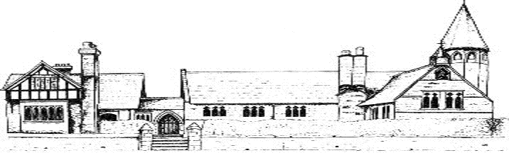

ECCLESTON CE PRIMARY SCHOOL
Let Your Light Shine
Geography Curriculum Statement
At Eccleston CE Primary School, we are united in our vision to prepare our children for life in the modern world. We will do this by instilling a lifelong love of learning and embedding Christian values that reflect the example Jesus has set. We strive for excellence in all we do, enabling all members of our school to flourish.
“Let your light shine”-Matthew 5.16

GEOGRAPHY AT ECCLESTON CE PRIMARY SCHOOL
Intent
At Eccleston CE Primary School, we believe that Geography helps to provoke and provide answers to questions about the natural and human aspects of the world. Children are encouraged to develop a greater understanding and knowledge of the world, as well as their place in it. Our geography curriculum enables children to develop knowledge and skills that are transferable to other curriculum areas and which can and are used to promote their spiritual, moral, social and cultural development. Geography is, by nature, an investigative subject, which develops an understanding of concepts, knowledge and skills.
The curriculum is designed to ensure that teaching equips pupils with knowledge about diverse places, people, resources and natural and human environments, together with a deep understanding of the Earth’s key physical and human processes. As pupils progress through the school, their growing knowledge about the world helps them to deepen their understanding of the interaction between physical and human processes, and of the formation and use of landscapes and environments. Geographical knowledge and skills are progressive and are sequenced to provide the framework and approaches that provide explanation of how the Earth’s features at different scales are shaped, interconnected and change over time.
We seek to inspire in children a curiosity and fascination about the world and its people which will remain with them for the rest of their lives, equipping them well for further education and beyond.

Implementation
Geography at Eccleston CE Primary School is taught in blocks throughout the year, so that children can achieve depth in their learning. Teachers have identified the key knowledge and skills of each blocked topic and theses are mapped across the school, ensuring that knowledge builds progressively and that children develop skills systematically. Tasks are selected and designed to provide appropriate challenge to all learners, in line with the school’s commitment to inclusion. At the end of each topic, key knowledge is reviewed by the children and rigorously checked by the teacher and consolidated as necessary.
Cross curricular outcomes in geography are specifically planned for and these are indicated on the whole school Geography End Points document. The Geography provision is also well resourced and specific resources are mapped to specific year groups and topics to support effective teaching and learning. The local area is fully utilised to achieve the desired outcomes, with extensive opportunities for learning outside the classroom embedded in practice
Impact
Pupils at Eccleston CE Primary School have knowledge, understanding and appreciation of their local area and beyond. They have an appreciation of life in other countries and cultures and are inspired to think about their own place in the world, their values and their rights. They have a deep understanding of the interaction between physical and human processes and how this affects landscapes and environments.
Geography in the Early Years
From an early age, children at Eccleston CE Primary School learn of different places, cultures and beliefs. They explore what makes them unique as well as discussing similarities and differences of their homes, families and where they are from. Utilising our outdoor area, children are encouraged on Muddy Mondays and Wellie Wednesdays to explore different features of the manmade and natural world and investigate how things change due to physical and human influences. We promote methods of caring for our world through recycling and litter picking and encourage the children to think about how we can make our environment pleasant and safe.

