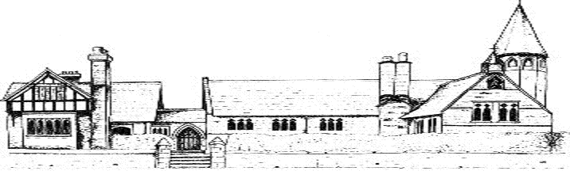

ECCLESTON CE PRIMARY SCHOOL
Let Your Light Shine
Modern Foreign Languages Curriculum Statement
At Eccleston CE Primary School, we are united in our vision to prepare our children for life in the modern world. We will do this by instilling a lifelong love of learning and embedding Christian values that reflect the example Jesus has set. We strive for excellence in all we do, enabling all members of our school to flourish.
“Let your light shine”-Matthew 5.16

MODERN FOREIGN LANGUAGES AT ECCLESTON CE PRIMARY SCHOOL
Intent
The National Curriculum aims to ensure that children;
- Understand and respond to spoken and written language from a variety of authentic sources
- Are able to speak with increasing confidence, fluency and spontaneity, finding ways of communicating what they want to say, including through discussion and asking questions, and that they are continually improving the accuracy of their pronunciation and intoncation
- Can write at varying length, for different purposes and audiences, using the variety of grammatical structures that they have learnt
- Discover and develop an appreciation of a range of writing in the language studied
- Children are encouraged to be investigative linguists, looking for cognates and words that they can link to their English vocabulary, giving them ownership of their own learning and fostering a curiosity for foreign languages and the history of how European languages have evolved
At Eccleston CE Primary School, we are committed to ensuring that competence in another language will enable our children to interpret, create and exchange meaning within and across cultures. The teaching of French from Year 2 upwards provides an appropriate balance of spoken and written language and lays the foundations for further Modern Foreign Language teaching at Key Stage 3.
Implementation
Children at Eccleston CE Primary School are introduced to formal French lessons from Year 2 and receive a weekly 45 minute lesson until they leave us in Year 6.
Children are taught to listen attentively to spoken language and respond, joining in with songs, rhymes and games. These might be used in knowledge based learning to reinforce and consolidate understanding of colour, number, the alphabet and basic greetings.
Children are exposed to a range of quality French literature and are encouraged to write accurate sentences and/or paragraphs. Speaking and listening is also an important part of our teaching and the children will be given appropriate opportunities to do this.
Impact
Our MfL curriculum ensure that children further develop their knowledge of where different languages, including the range of home languages spoken by our school families and the French language, are spoken in the world. In ensuring an emphasis on oracy, speaking listening and written activities, children become more competent and confident language users.
Modern Foreign Languages in the Early Years
In Early Years, we believe it is important for our children to learn about other backgrounds, cultures and traditions and this includes other languages. We provide many opportunities for children to explore the wider world around them through stories, visitors and other activities. During registration, children are introduced to a range of ‘Good mornings’ including those home languages of peers in their class. We also provide a range of dual language books so that children with additional language feel a sense of familiarity, as well as providing new experiences for all children.

