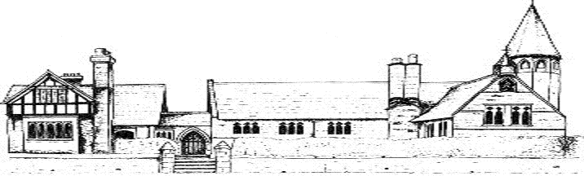

ECCLESTON CE PRIMARY SCHOOL
Let Your Light Shine
Music Curriculum Statement
At Eccleston CE Primary School, we are united in our vision to prepare our children for life in the modern world. We will do this by instilling a lifelong love of learning and embedding Christian values that reflect the example Jesus has set. We strive for excellence in all we do, enabling all members of our school to flourish.
“Let your light shine”-Matthew 5.16

MUSIC AT ECCLESTON CE PRIMARY SCHOOL
Intent
The National Curriculum for music aims to ensure that all children;
- Perform listen to, review and evaluate music
- Be taught to sing, create and compose music
- Understand and explore how music is created, produced and communicated
At Eccleston CE Primary School, children gain a firm knowledge and deep appreciation of what music is through listening, singing, playing, evaluating, analysing and composing across a wide range of historical periods, styles, traditions and musical genres. We want to develop a curiosity for the subject, as well as an understanding and acceptance of all types of music. We want our children to understand the value and the importance of music in the wider community and that they are able to use their musical skills, knowledge and memorable experiences to involve themselves in music in a variety of different contexts.
Implementation
At Eccleston CE Primary School, our curriculum ensures that our children sing, listen, play, perform, compose and evaluate. Our curriculum is carefully mapped out to ensure that all skills are covered and also incorporates a wide range of musical genres for appraisal and songs to learn and perform.
During weekly music lessons, children are taught the elements of music so they are able to use some of the appropriate language of music to dissect it and understand how it made, played and appreciated.
Children from Year 2 upwards are taught to play the recorder and to read treble clef notation, musical direction and a range of musical vocabulary. Children also have the opportunity to learn a wind or brass instrument through the Wider Opportunities program and we also work closely with Music for Life to provide instrumental lessons for children who request them. Pupil Premium money can also be used for individual instrumental tuition for those children who we feel would benefit.
Children learn how to compose with body percussion, vocal sounds, tuned and untuned percussion and recorders. Singing skills are taught across school so that children understand the importance of warm ups, posture, breathing, enunciation and expression.
Through the musical program Charanga, inclusive lessons are provided to allow children to access our curriculum in a fun and engaging way.
Children are given opportunities to perform to their peers, their parents and the wider community. We perform at our own outdoor theatre, the school hall, the Village Hall and the Storyhouse professional theatre in Chester.
Impact
Our pupils have access to a varied musical curriculum which allows them identify areas of strength and talent as well as areas they may wish to improve upon. The integral nature of music and the learner creates a rich palette from which our children may access traits such as self-confidence, performance skills, well-being and self-reflection as well as developing cultural capital for all.
Music in the Early Years
From the beginning of their career in school, children are given opportunities to explore and play with a wide range of musical instruments as well as exploring their own thoughts ideas and feelings through a variety of activities. All children are encouraged to explore music through the singing of a range of songs, making their own music and performing for their peers and wider audiences.

