Eccleston CE Primary School
Governors’ Prayer

We sit down together tonight as one body, one team, in unity.
Grant that we may work with each other and that the room e are in may not house discord or bad feelings
Gift us with the ability to listen without preconception to each other and guide us through difficult decisions that may affect the children of our school.
We pray that these decisions will be made with pupils, staff and parents in mind, and that there will not be suffering or prevention of learning as a result of them.
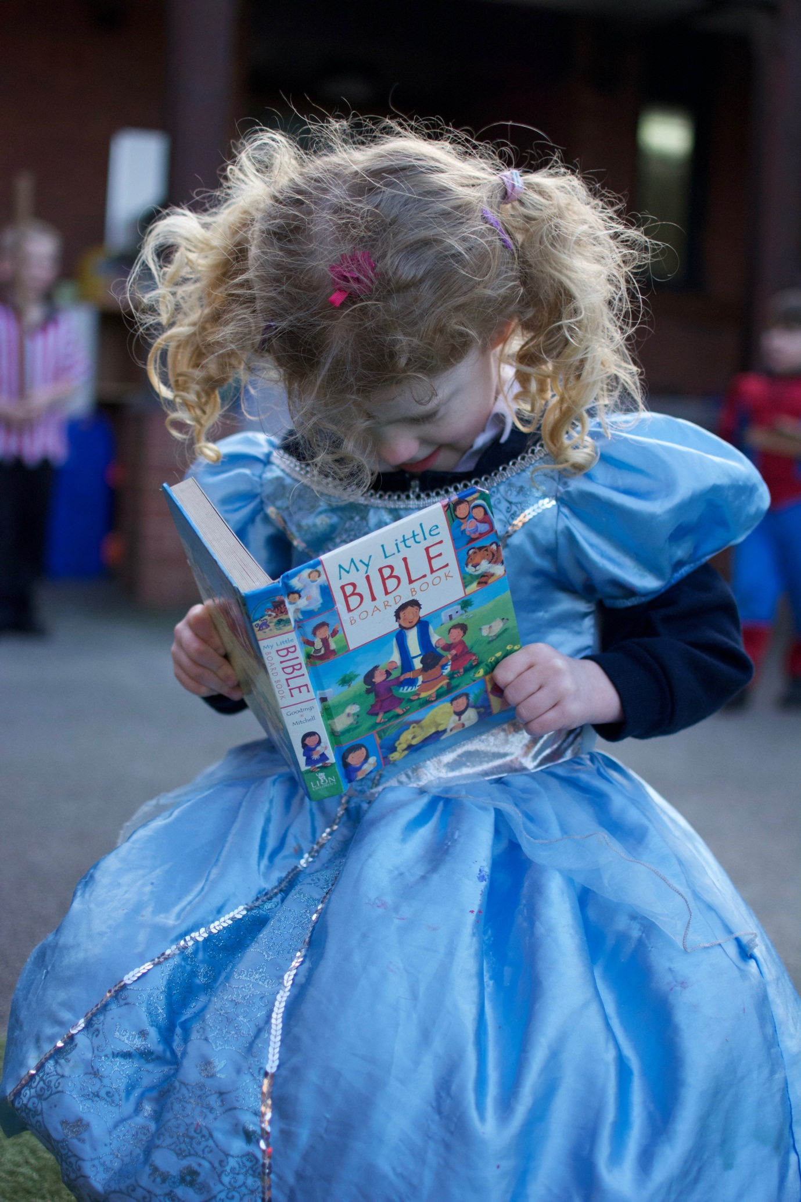
Clear our minds from jealousy, timidity, spite, hatred, laziness and anything else that might attempt to prevent us from speaking the truth.
May we be given courage to say what needs to be said, wisdom, so that we may distinguish between right and wrong and, finally, may we be blessed with your love.
In the name of the Father, the son and the Holy Spirit.
Amen

